A Blockchain Based System for Safe Food Supply & Supervision

Food supply & production plays a major role in any countries development as its help in increasing countries business and healthy supply make countries youth stronger but sometime some corrupt companies can produce fake product by utilizing genuine product labels or can modify expiry date labels which can leads to customer dissatisfaction and can hinder countries revenue growth.

Currently all supply product details are managing in single centralized server whose database can be manipulated with fake product or fake expiry by giving bribe to corrupt database managing employees. There is no tool exists to detect database manipulation and this single server can also be hacked by attackers and data will be lost.

To overcome from above disadvantages we are proposing Blockchain based system to manage all supply chain food product details. Blockchain has inbuilt support for data security (data will be secured in the form of encryption), reliability (data will be stored at multiple nodes in decentralized fashion and if one node down then data can be access from other working nodes) and transparency (data cannot be alter in any manner and called as tamper proof).

Blockchain store each records as block/transaction and associate each block with unique hash code. Blockchain utilize this hash code for verification of all existing blocks and this verification of PROOF OF WORK algorithm makes Blockchain tamper proof.

We can interact with any Blockchain technology tool such as Hyper Ledger or ETHEREUM by utilizing SMART CONTRACTS and this contracts contains function which can be called to store or retrieve data from Blockchain.

In propose work to manage supply chain data we have designed following modules

1. Admin: admin can login to system by using username and password as ‘admin’ and ‘admin’. After login admin will add details of all supply chains partners (stakeholders) and give login details to each partners. This partners can be raw material suppliers or farmers, Manufacturer, Retailers and Distributors. Admin will generate orders for required supply and can run ML algorithms to predict or forecast demand of particular product in future. Admin can view details of all available partners and can view all tracing details of product processing in the map.
2. Stakeholder Raw Material Supplier login: Raw material supplier will receive order from admin and then forward all raw materials to ‘MANUFACTURER’ and all this trace details will be updated in Blockchain.
3. Manufacturer Login: can login to system and receive raw material and can manufacture product and supply to distributor
4. Distributor Login: can login to system and can distribute product to Retailer
5. Retailer Login: can login to system and then sale product to N consumer
6. Consumer or any government official: by using product ID can trace all details of the product.
7. Recommendation: any consumer can run this module to get recommendation of particular purchase items. If he purchase beef then he will enter BEEF and system will recommend ‘Chicken’ as he may purchase chicken also.

To manage above details in Blockchain we have designed following Smart Contract

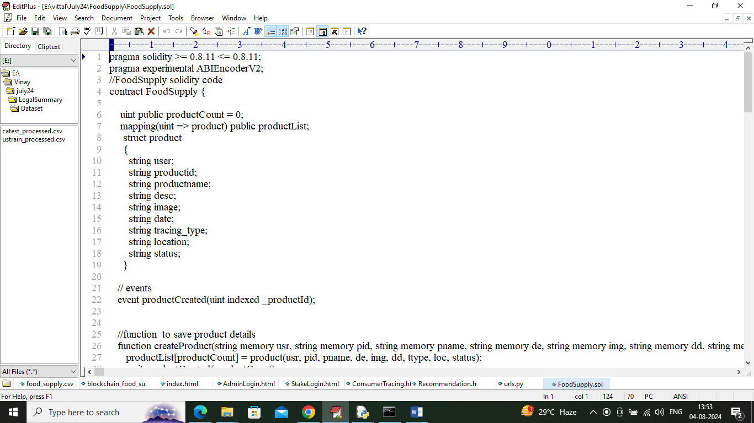

In above contract we have defined functions to manage and trace all details of a product and now we need to deploy above contract in ETHEREUM Blockchain by using below steps

1. First go inside ‘hello-eth/node-modules/bin’ folder and then look for file called ‘runBlockchain.bat’ file and then double click on that file to get below screen
2. 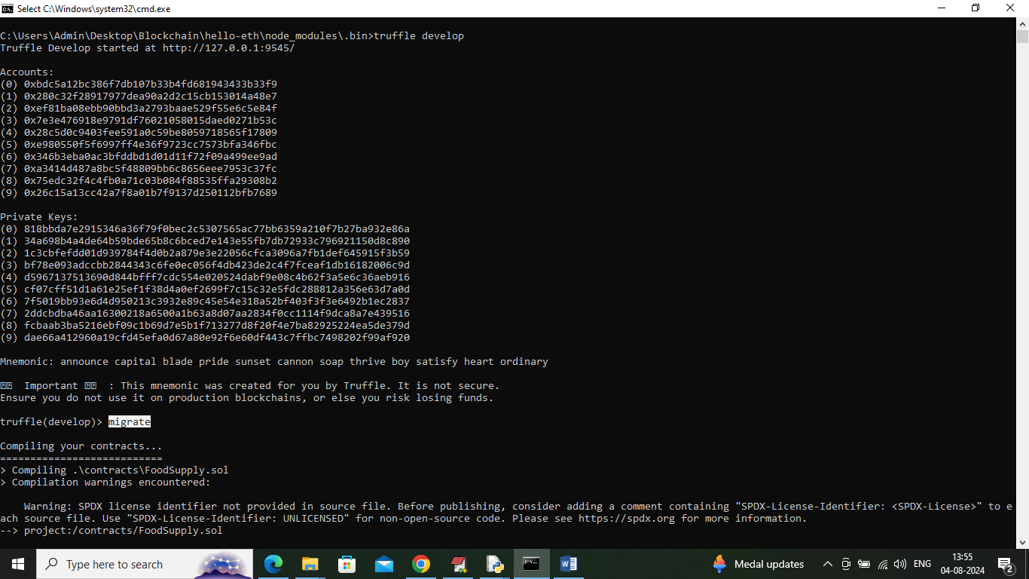
3. In above screen ETHEREUM started with default accounts and keys and now type command as ‘migrate’ and press enter key to get below page
4. 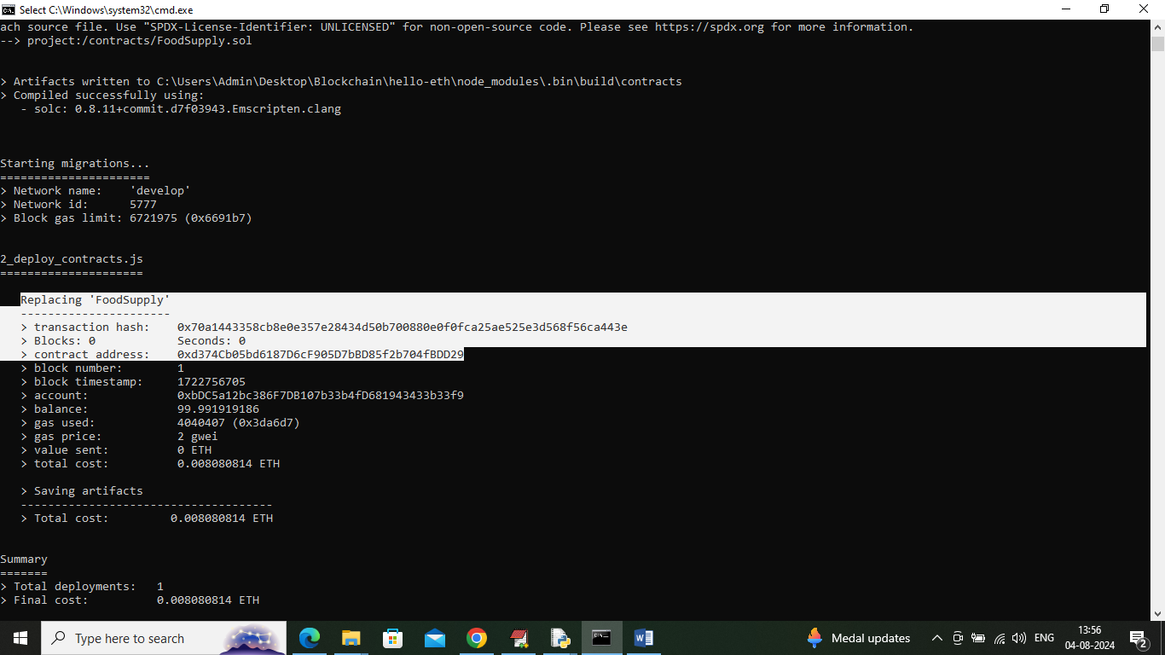
5. In above screen in white colour text can see ‘Food Supply’ contract deployed and got contract address also and this address need to specify in python code to call that contract. In above screen showing python code calling above contract using address
6. 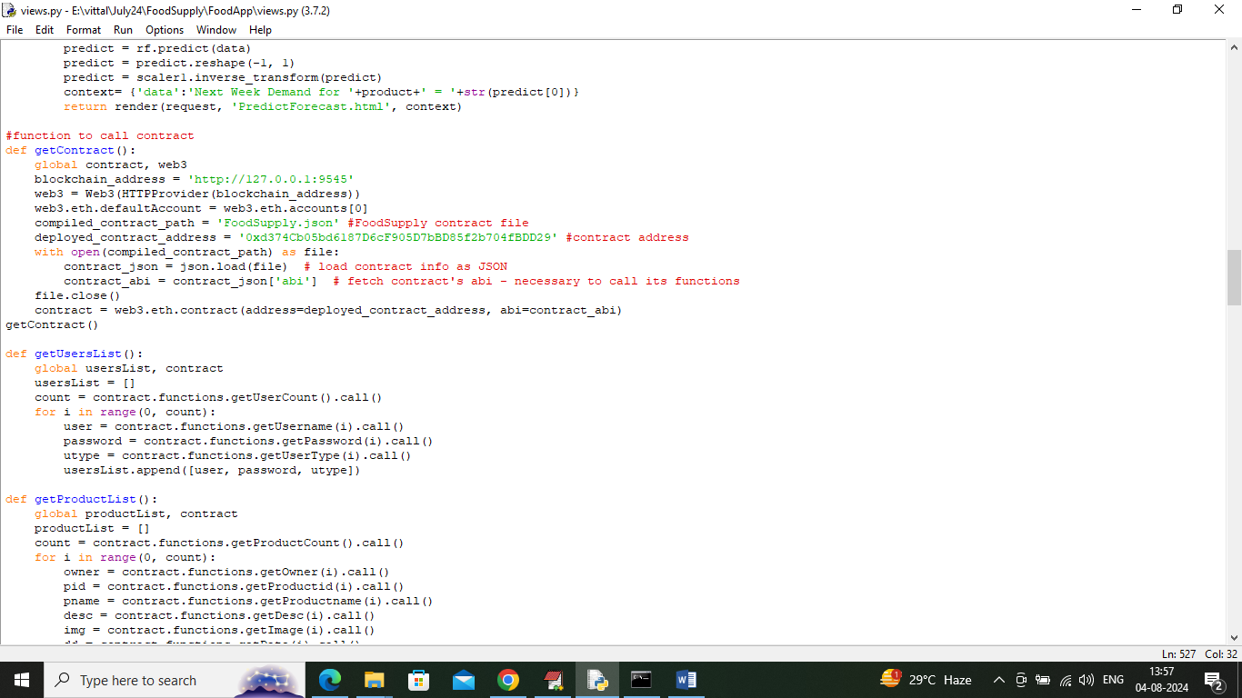
7. In above screen read red colour comments to know about contract calling and in above screens we have seen contract deployed and running and let that contract running. Now double click on ‘run.bat’ file to start python server and get below page
8. 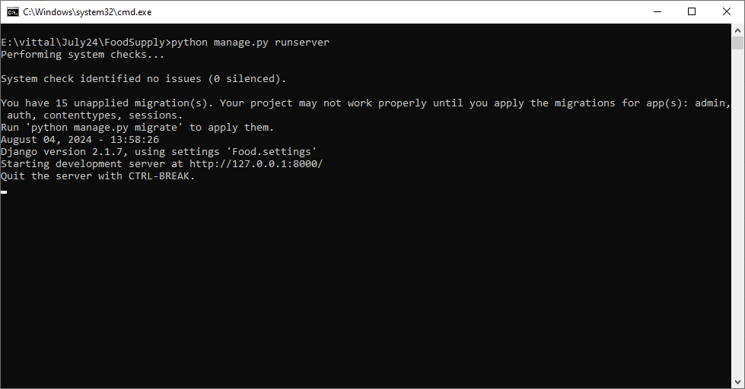
9. In above screen python server started and now open browser and enter URL as <http://127.0.0.1:8000/index.html> and press enter key to get below home page

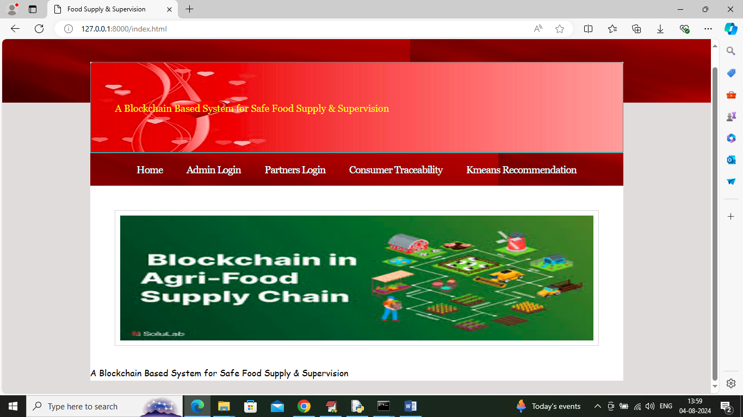

In above screen click on ‘Admin Login’ link to get below login page

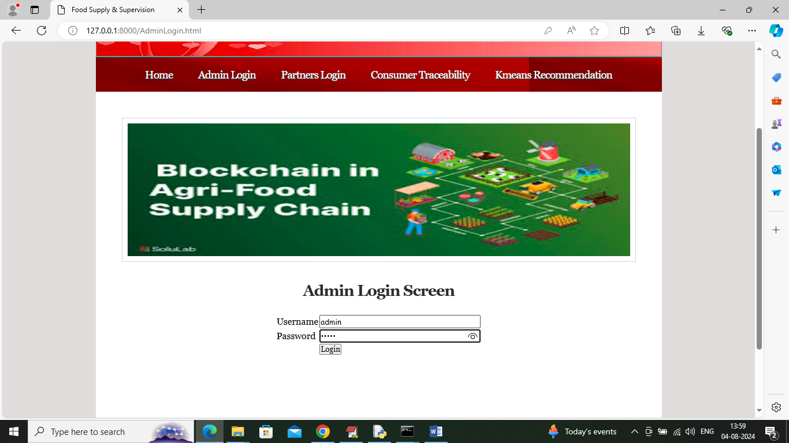

In above screen admin is login and after login will get below page

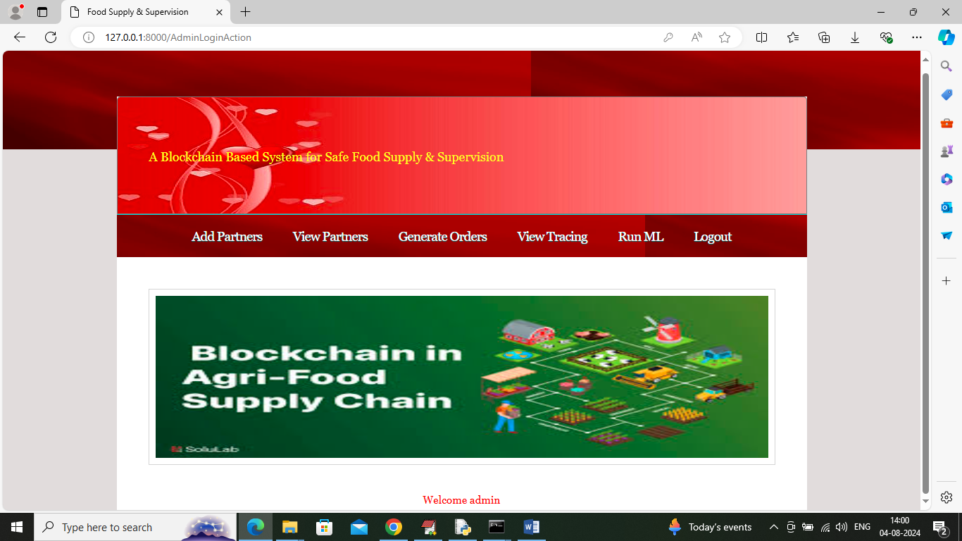

In above screen admin can click on ‘Add Partner’ link to get below page

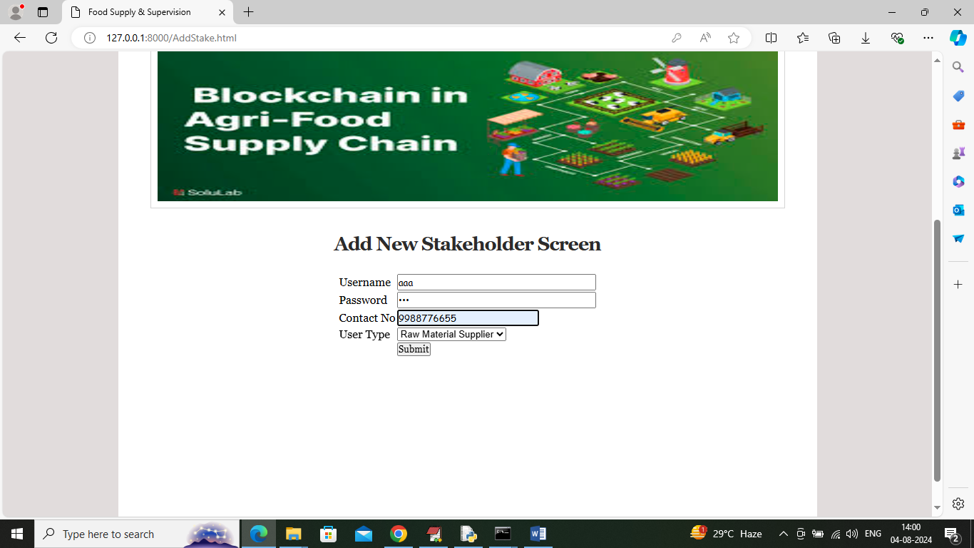

In above screen admin is adding details of ‘Raw Material’ partner and then click on button to save details in Blockchain and get below page

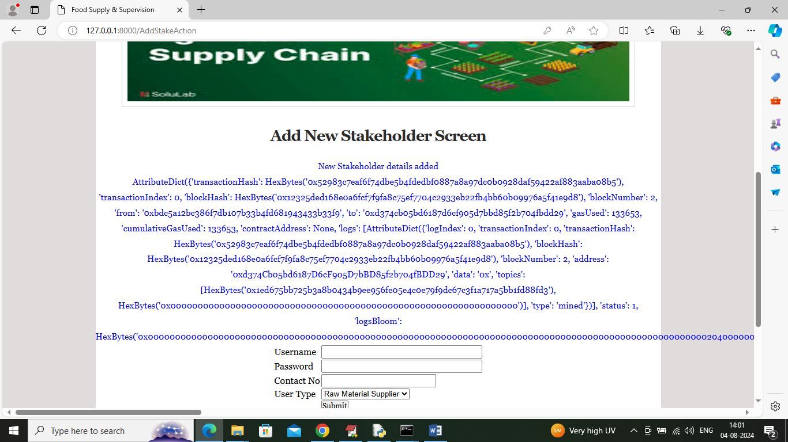

In above screen new stake holder or partner details added to Blockchain and for your guide and your understanding purpose I am displaying entire logs returned by Blockchain after storage. In above blue log can see Transaction no, block no, hash code and many other details. Similarly you can add other partner details like Manufacturer, retailer etc. Now admin can click on ‘View Partners’ link to view all partners’ details and get below page

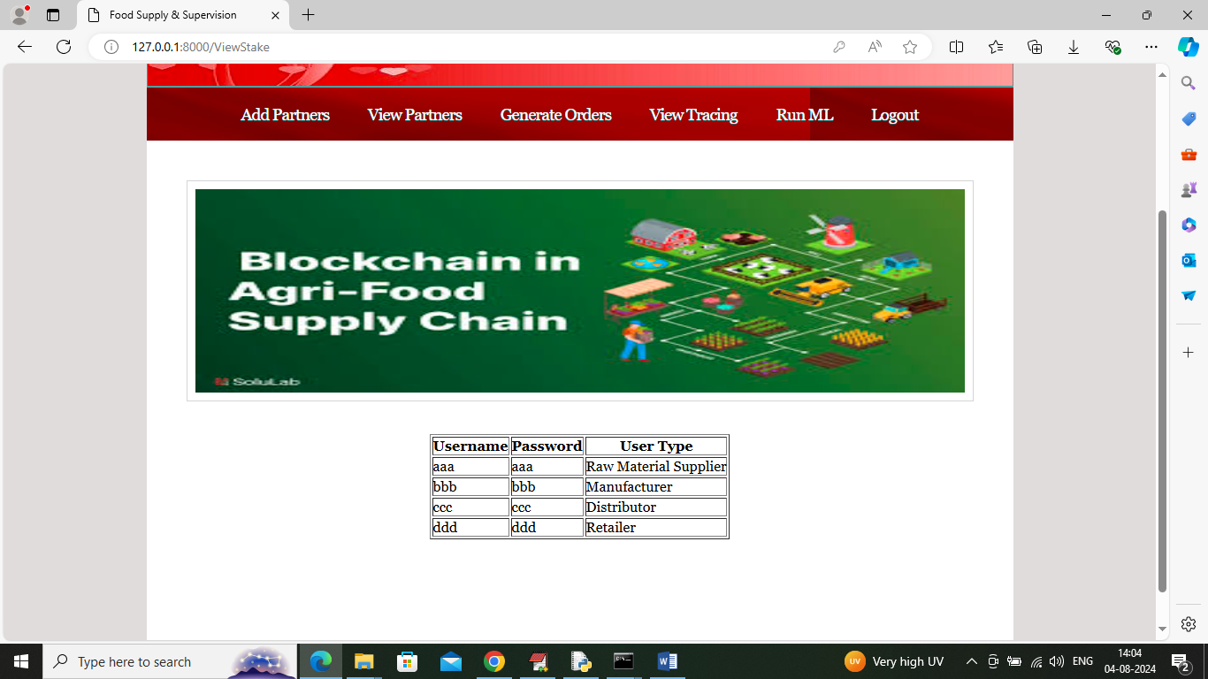

In above screen admin can view details of all added Partners and now click on ‘Generate Orders’ link to get below page

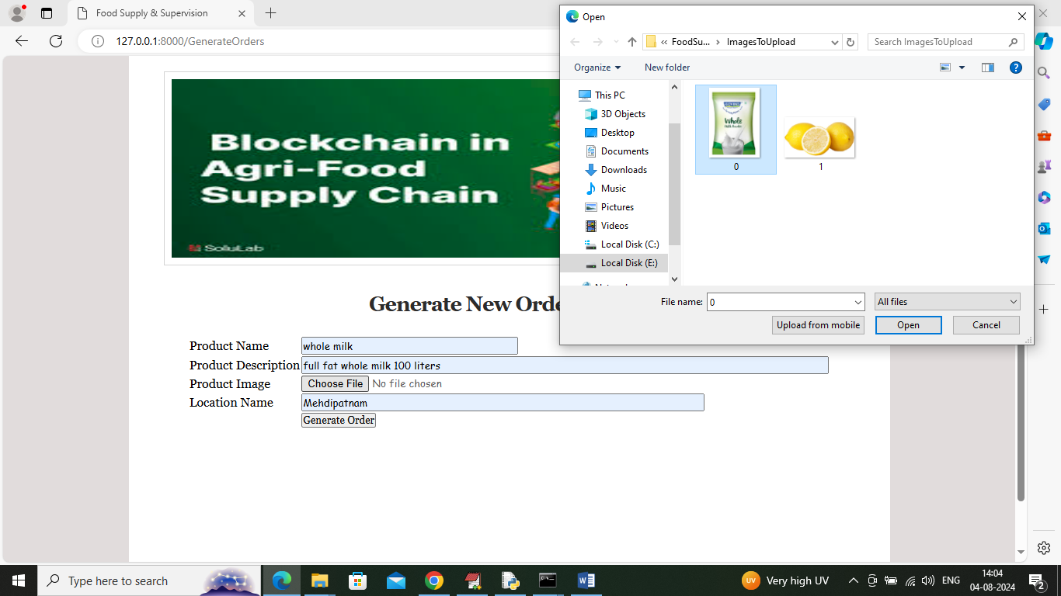

In above screen admin is generating order and adding order generated location so consumer can trace the location of each process of product (note: here we don’t have GPS in laptop so manually entering location). Admin will upload related product image and then press button to record order in Blockchain and get below page

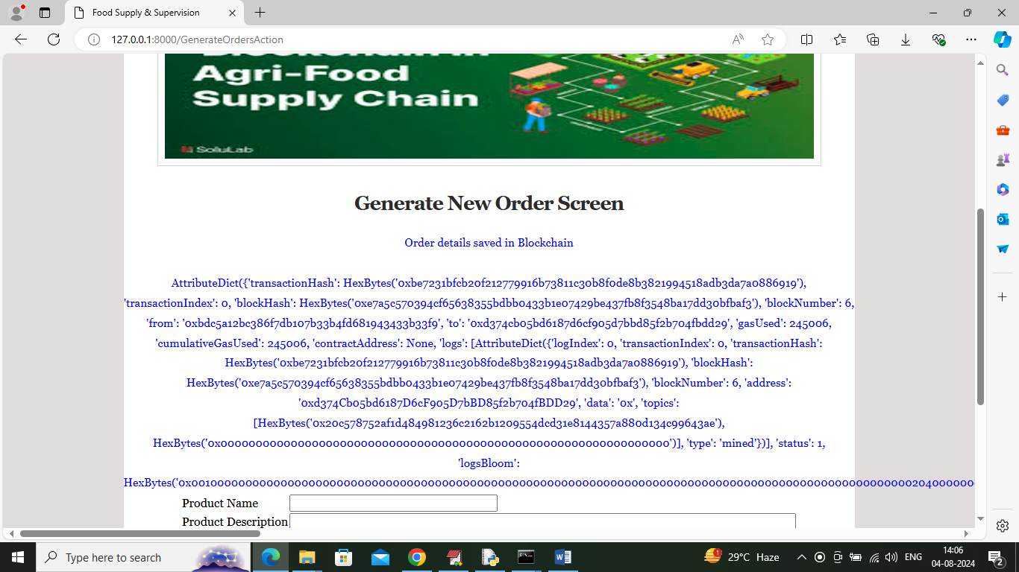

In above screen admin can see product order generated and can see all stored logs of Blockchain. Now click on ‘View Tracing’ link to get below page

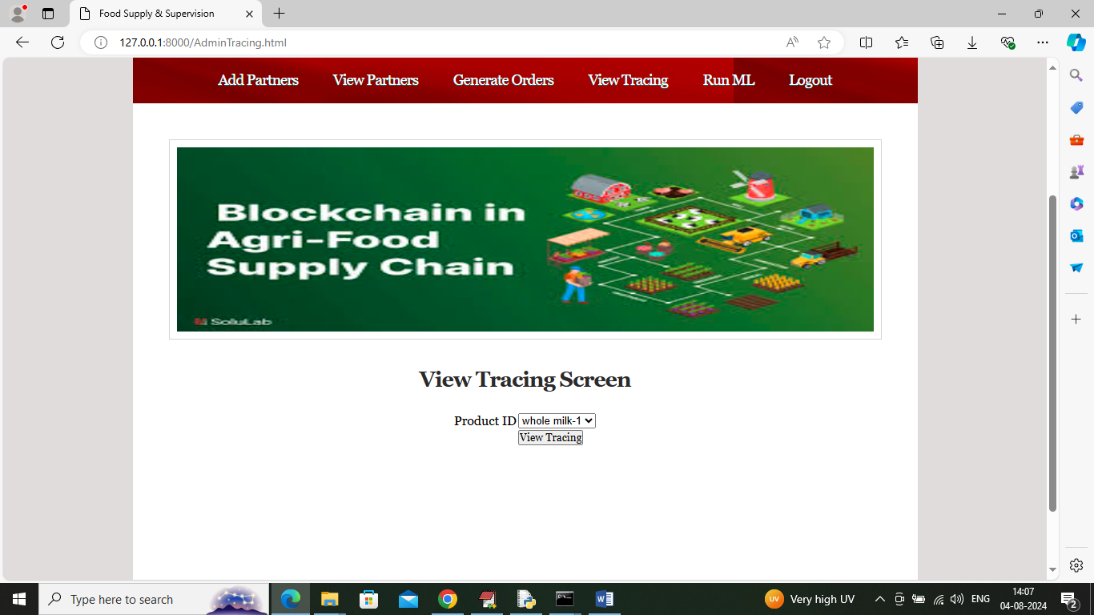

In above screen admin will select desired product ID and then press button to get below page

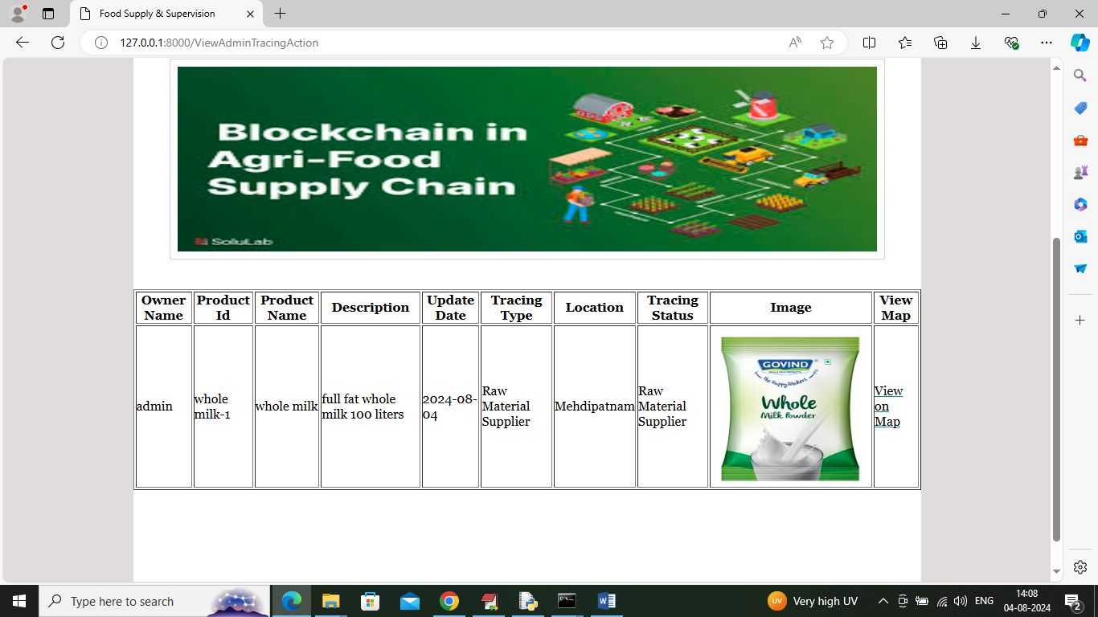

In above screen admin will see the tracing of order which went to Raw Material Supplier who will login and receive order to further process and admin can click on ‘View on Map’ link to view generated order location in map like below page (this you can consider as enhancement)

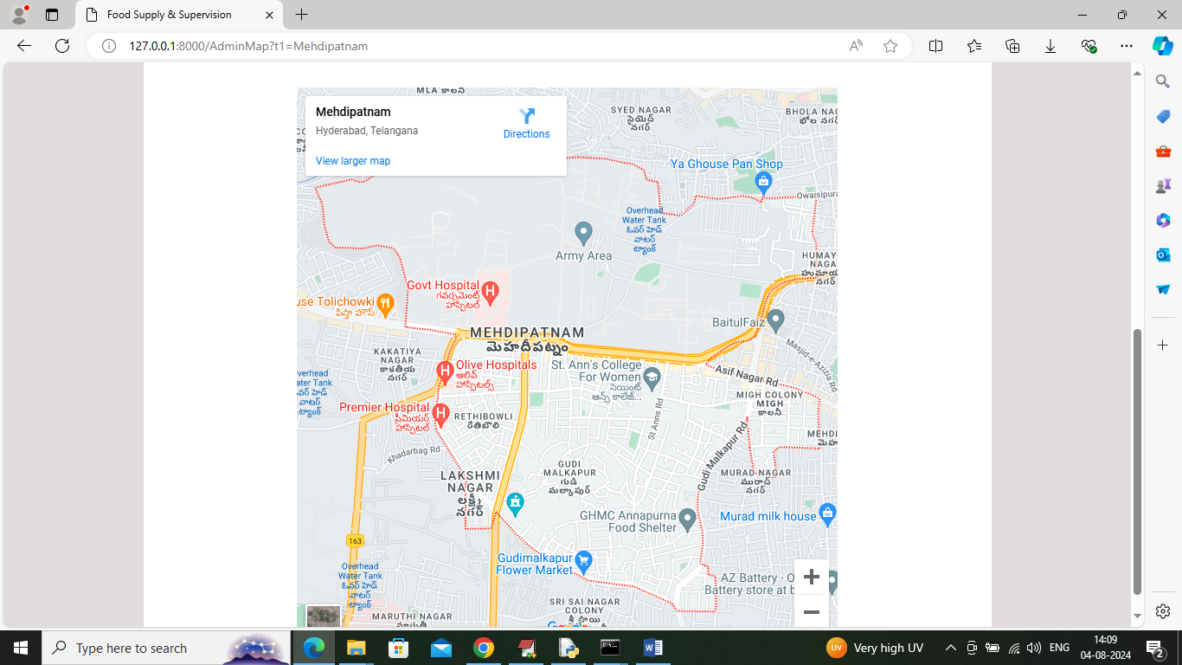

In above screen can see order generated location MAP and now admin can click on ‘Run ML’ link to get below page.

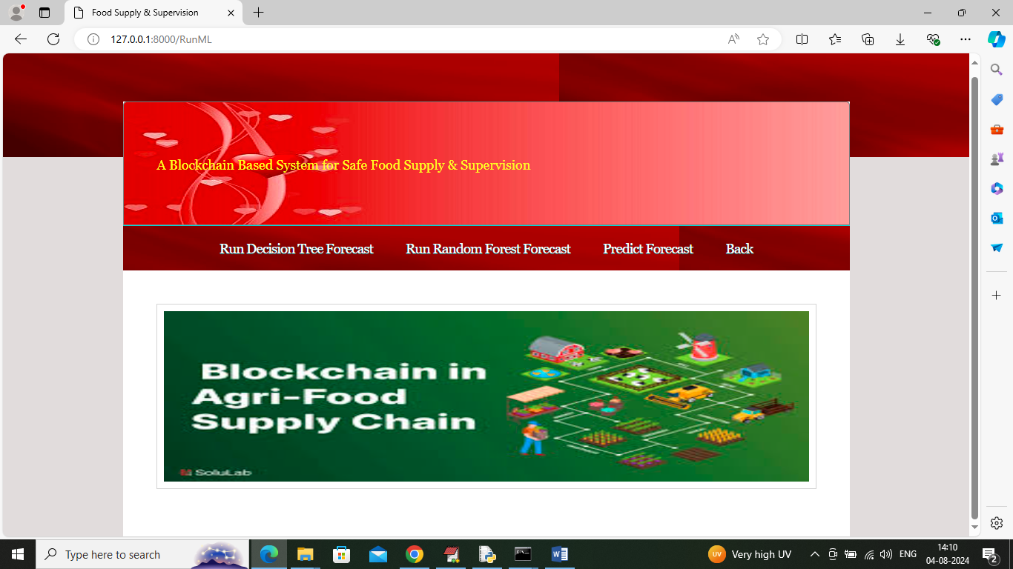

In above screen admin can click on ‘Run Decision Tree’ link to train Decision tree on dataset to forecast product demand and get below page

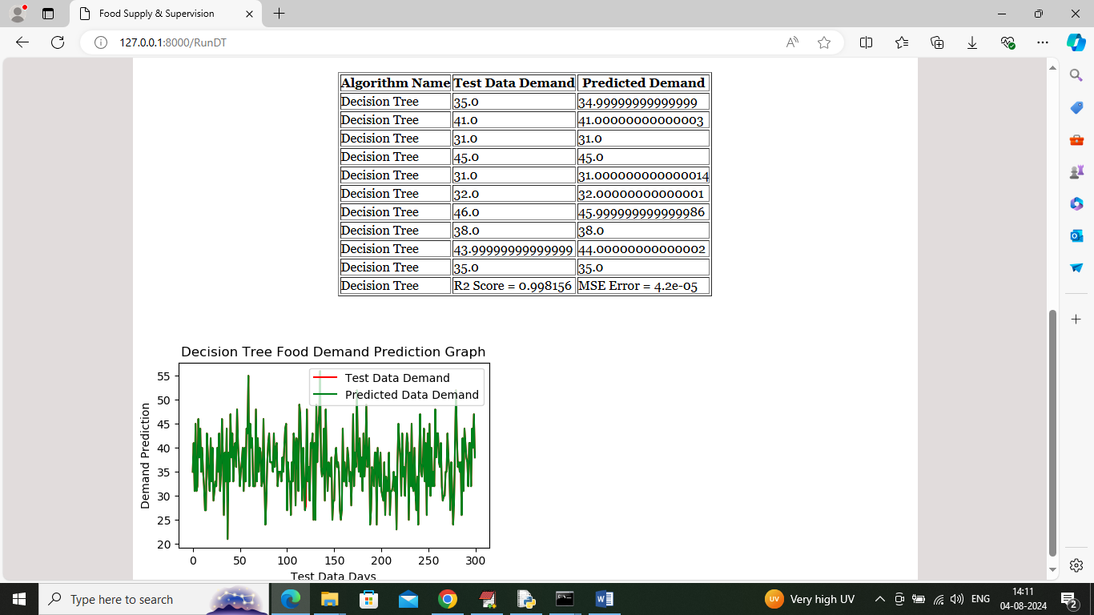

In above screen can see forecast result of decision tree where tabular output contains forecast of next 10 days and in that table we are showing algorithm name along with TEST data demand and predicted demand and can see both test and predicted values are very closed and in last row can see Decision Tree R2 Score as 99% and can see MSE error also. In graph x-axis represents number of days and y-axis represents forecast values and then red line represents TEST data demand value and green line represents Predicted demands and can see both lines are fully overlapping so we can say both test values and predicted values are accurate. Now click on ‘Run Random Forest’ link to train Random Forest and get below page

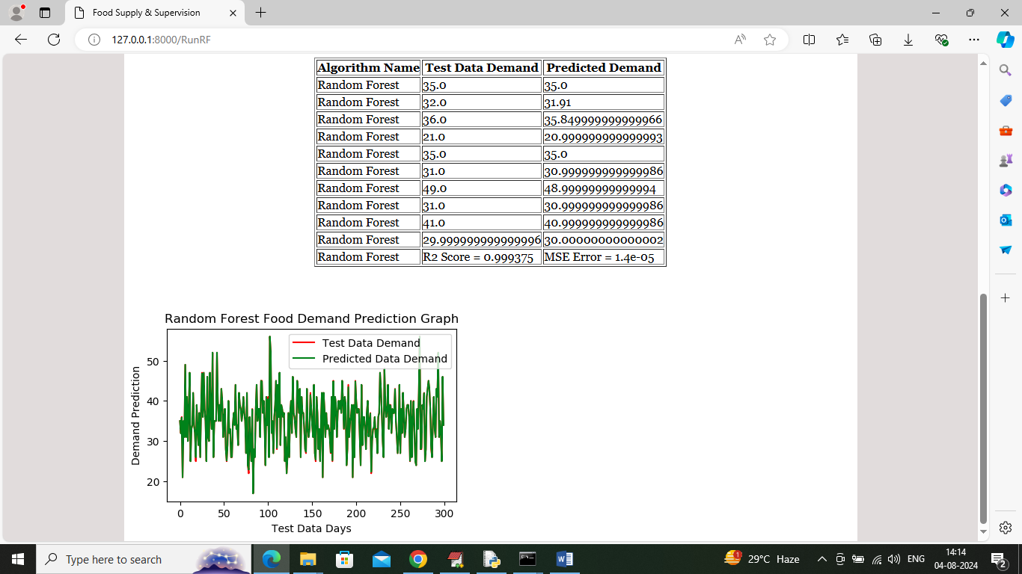

In above screen can see result or Random Forest algorithm and in last row can see R2Score which is slight higher than Decision tree and can say Random Forest is better than Decision tree and now click on ‘Predict Forecast’ link to get below page

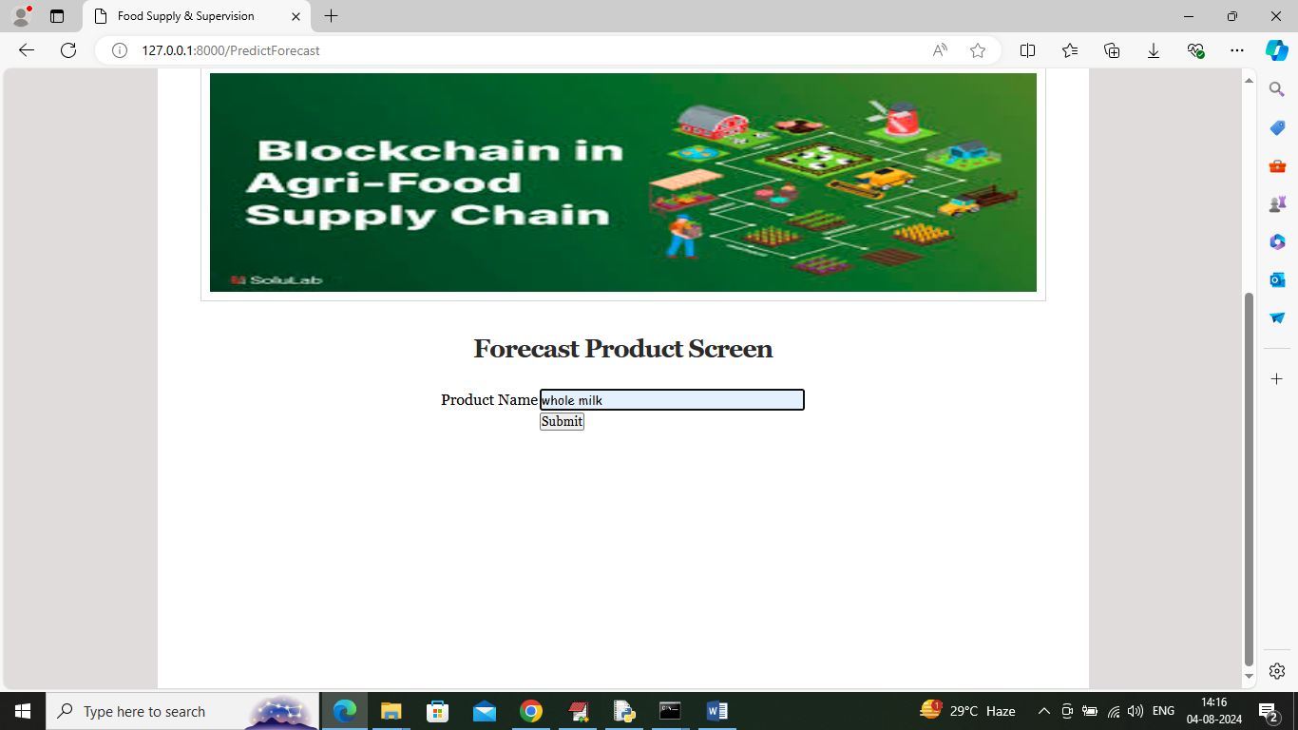

In above screen user will enter some product name and then will get below forecast

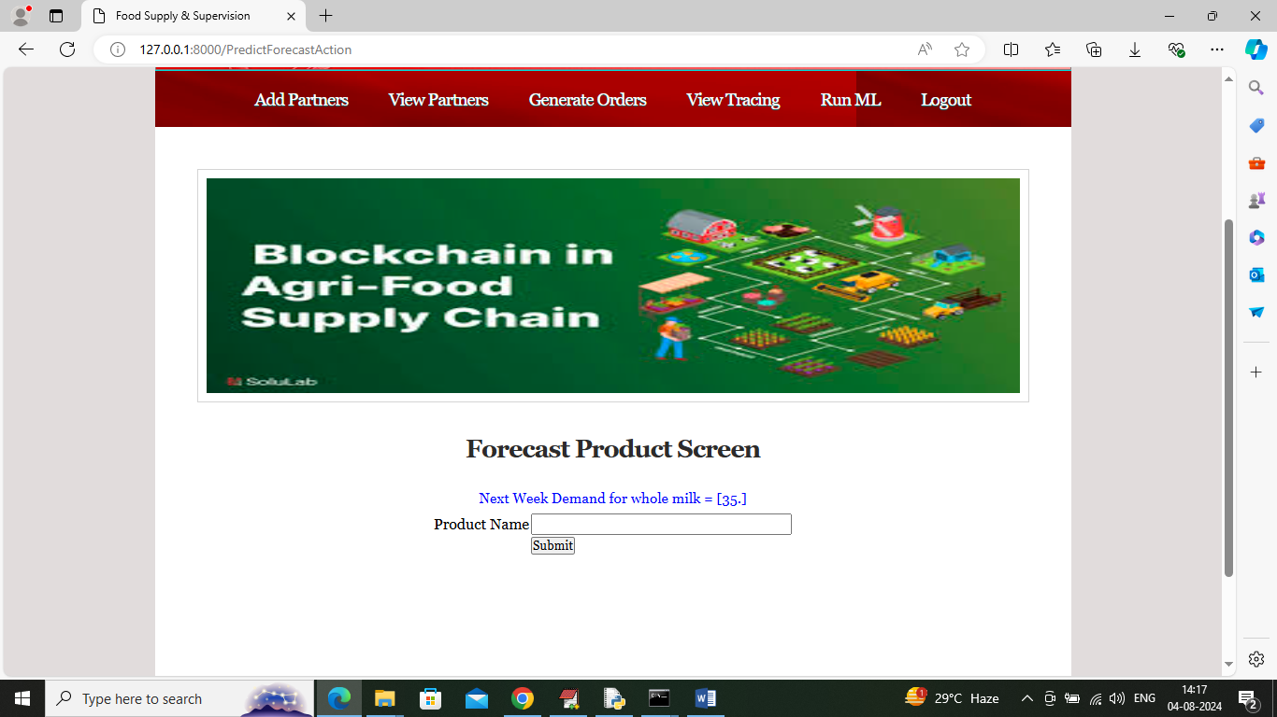

In above screen in blue colour text can see next day prediction is 35 litres and similarly enter any product details and get below output

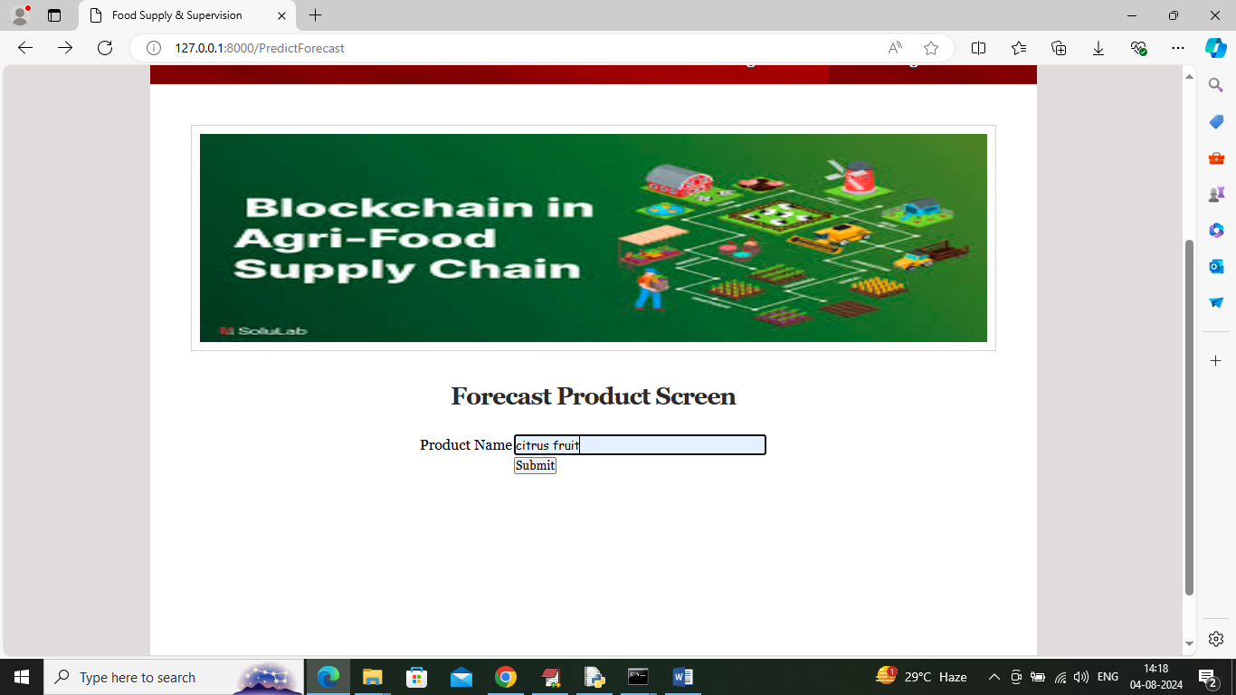

In above screen entering product name as ‘Citrus Fruit’ and below is the forecast output

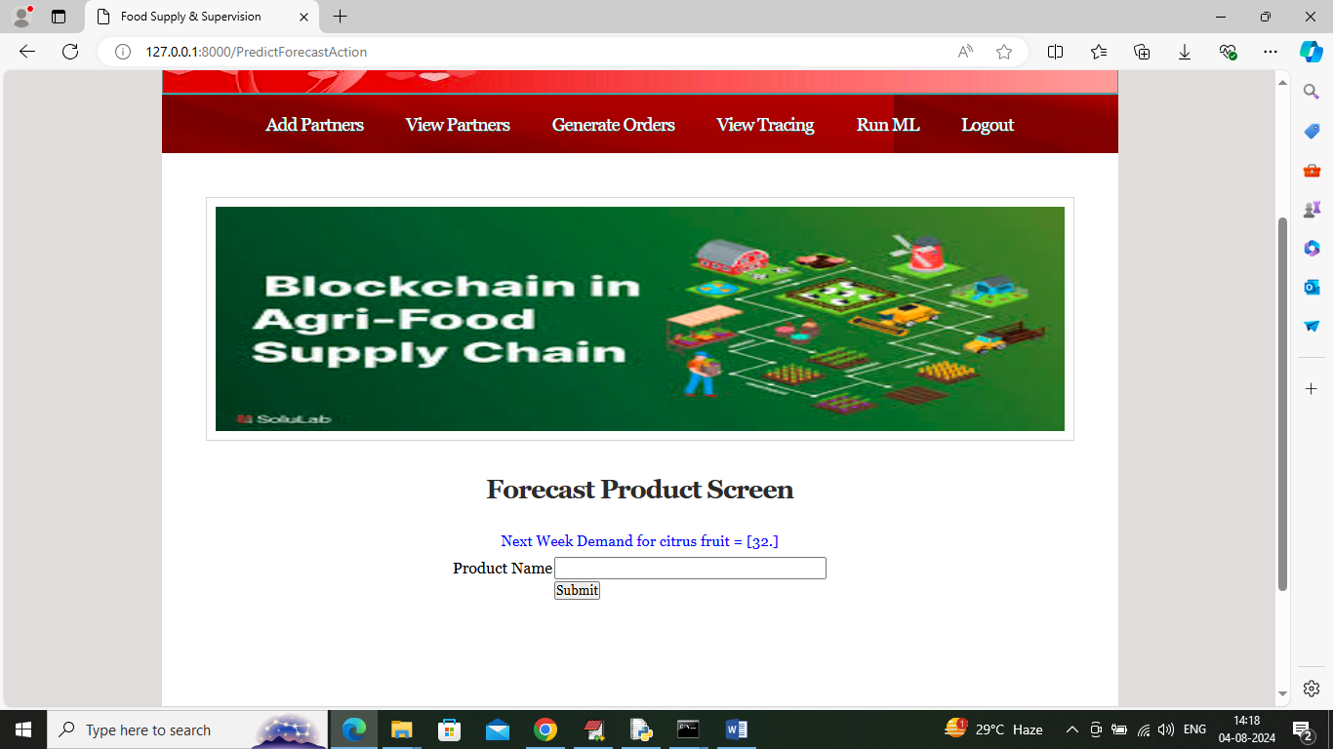

In above screen citrus fruit next day demand is 32 pieces. To train above algorithms and to know about product names you can see dataset file available inside ‘dataset’ folder. This dataset showing in below screen

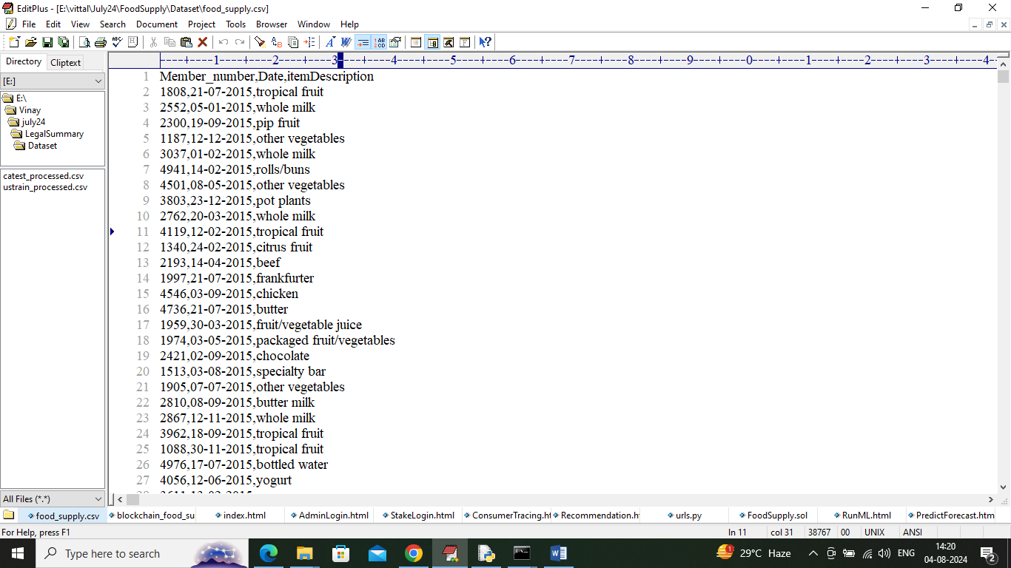

In above dataset screen whatever product names you are seeing you can input to application for forecast. Now logout and login as various partners for further product order processing

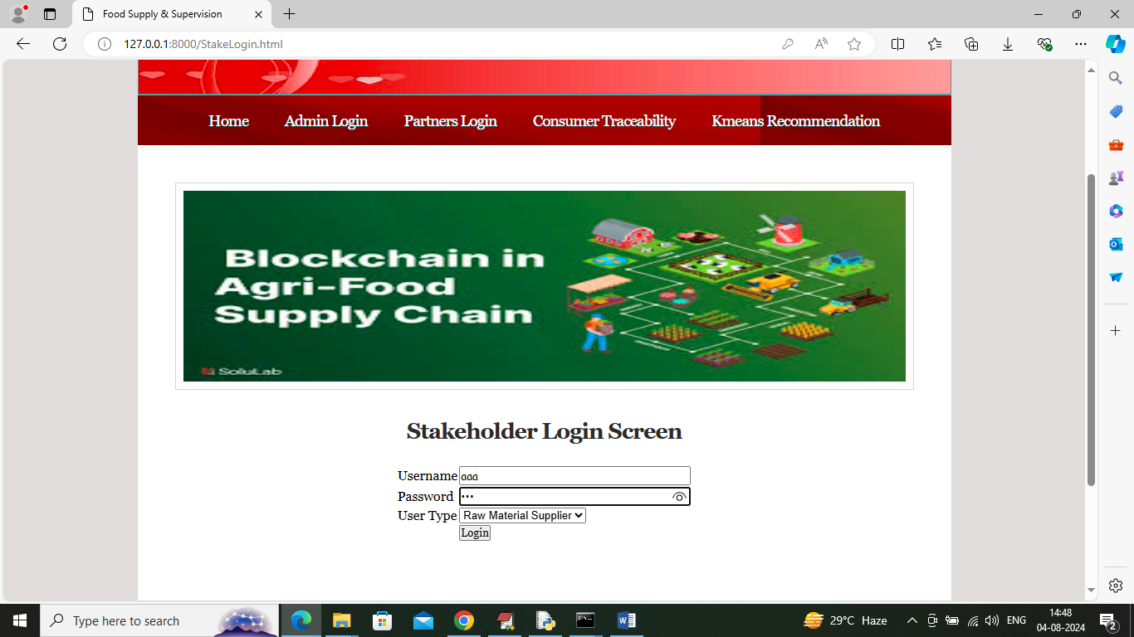

In above screen click on ‘Partners Login’ and then login as Raw material supplier to get below page

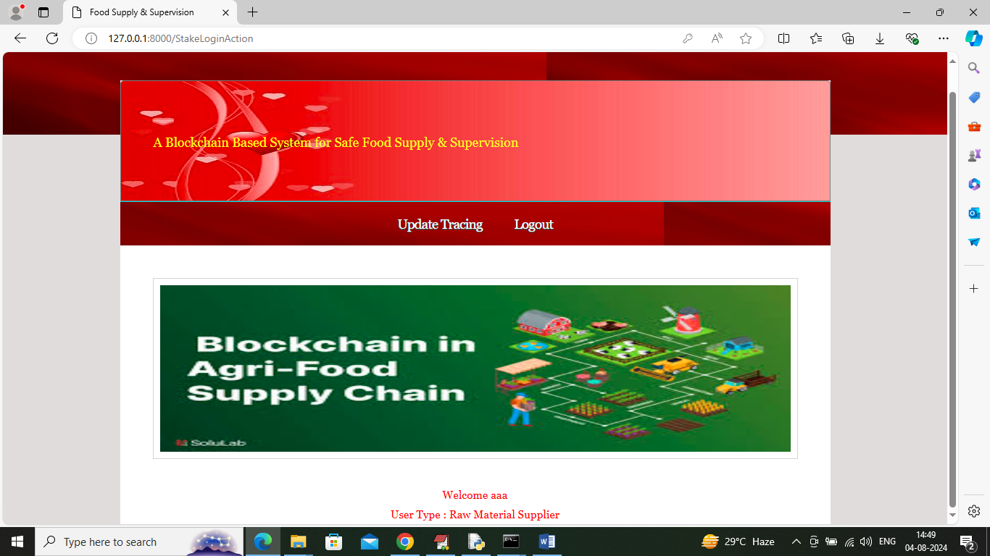

In above screen Raw Material supplier can click on ‘Update Tracing’ link to get below page

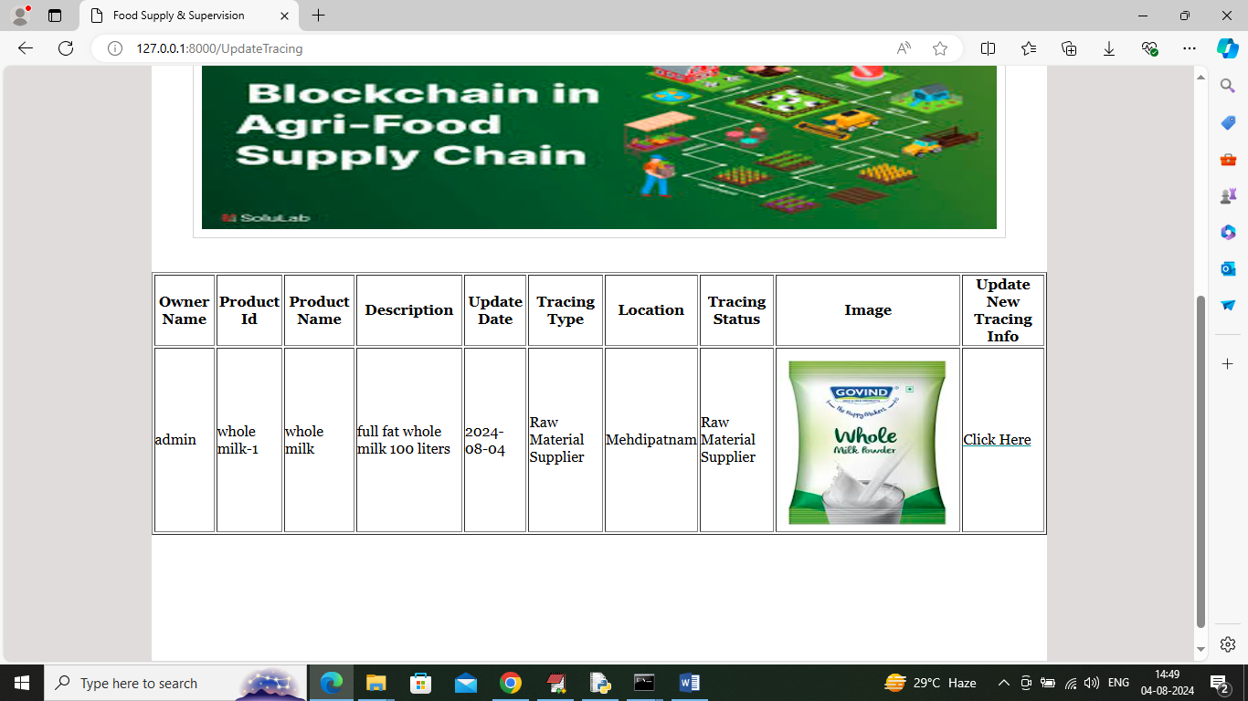

In above screen raw material supplier can click view receive order details and then click on ‘Click Here’ link to supply raw material to manufacturer

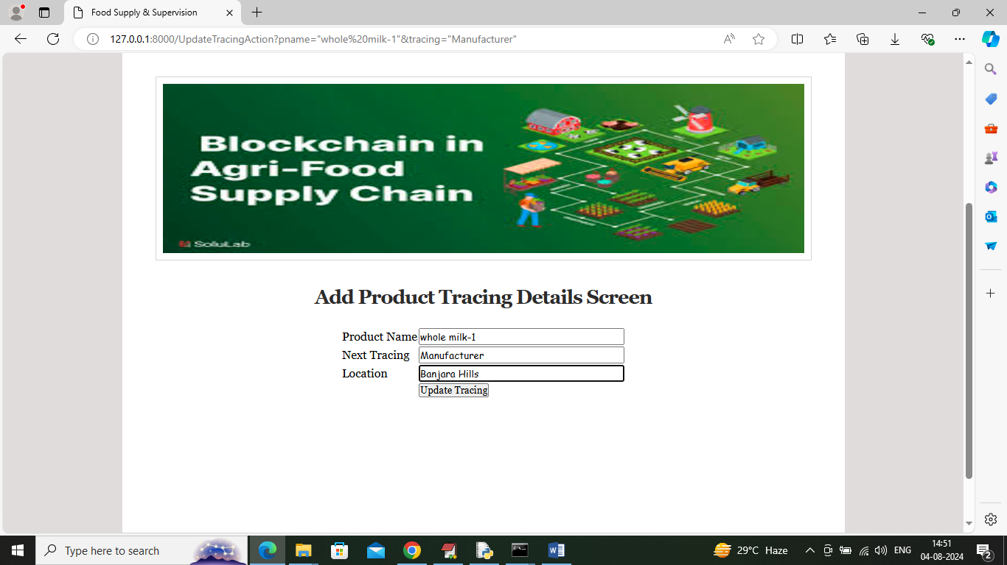

In above screen raw material supplier updating trace to Manufacturer and then Click on ‘Update Tracing’ button to record trace in Blockchain and get below page

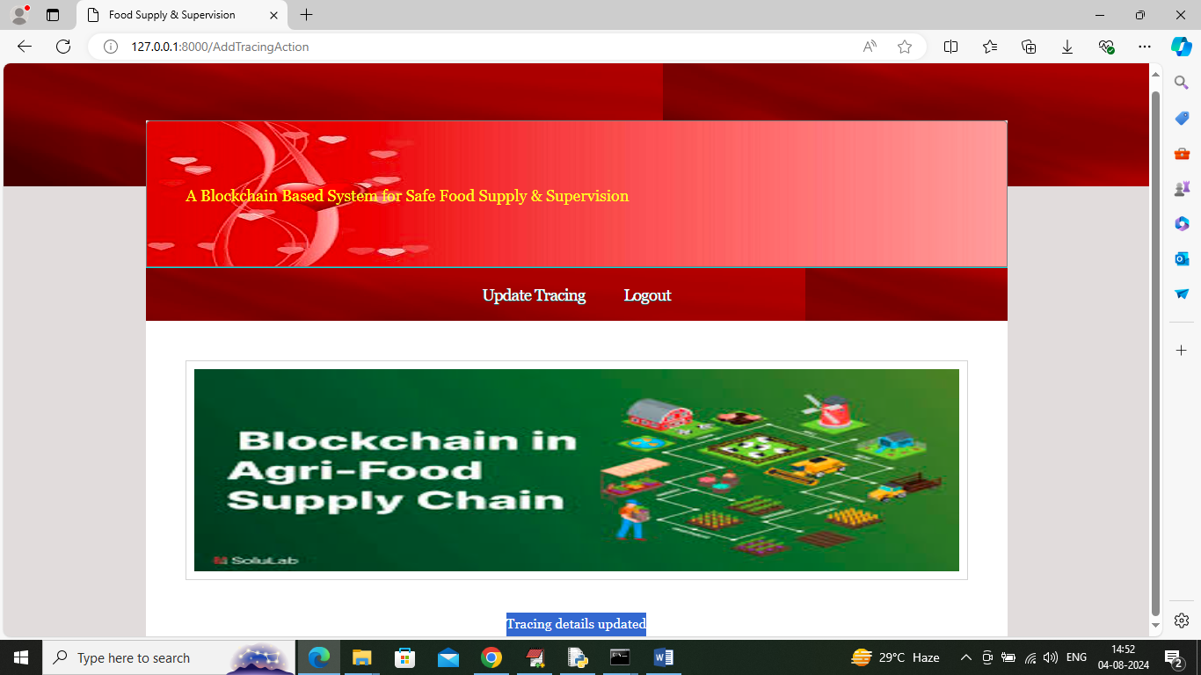

In above screen tracing details updated and now logout and login as ‘Manufacturer’ to manufacture order and to process further

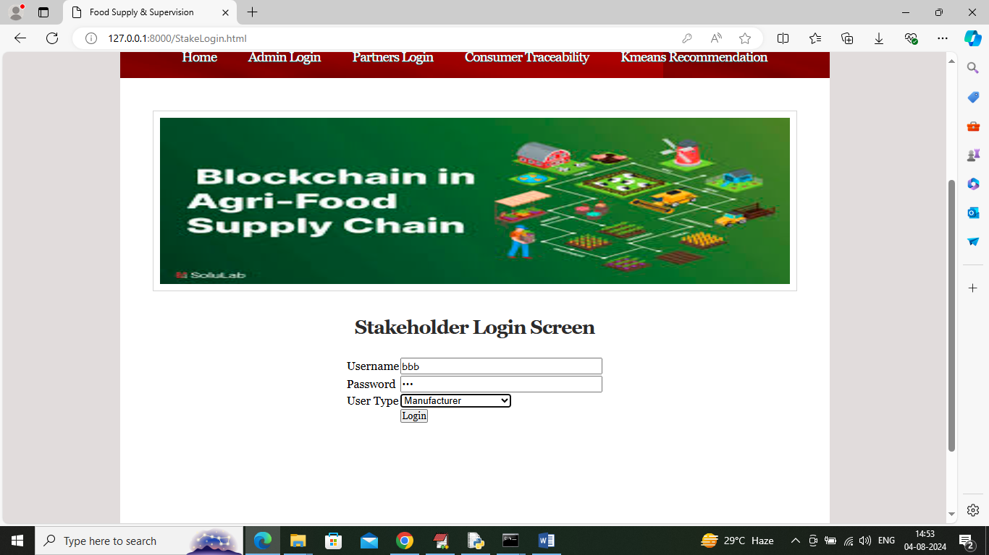

In above screen manufacturer is login and after login will get below page

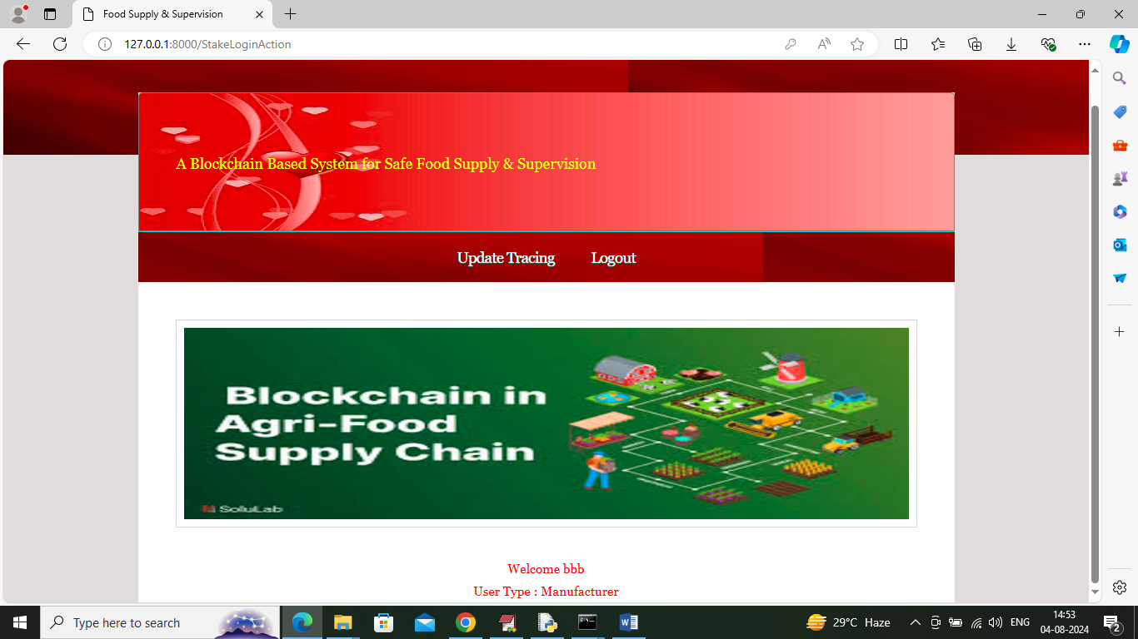

In above screen manufacturer will manufacture product and then update trace in below screen by clicking on ‘Update Tracing’

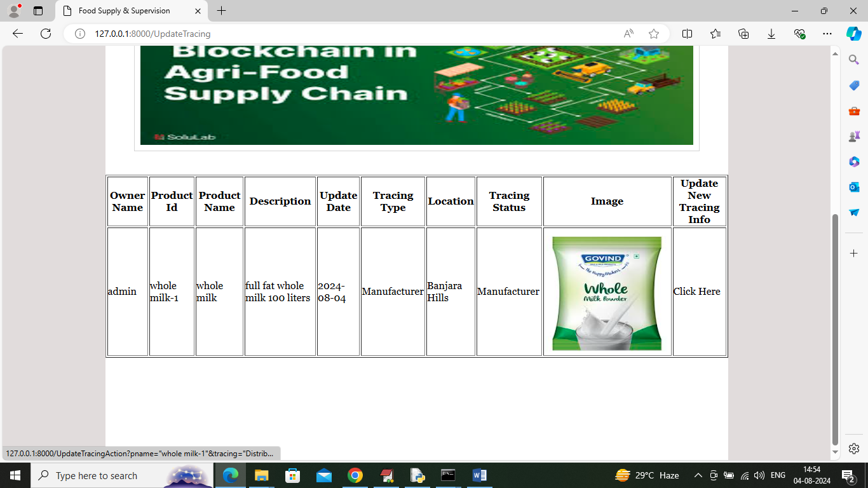

In above screen click on ‘Click Here’ link to update further process

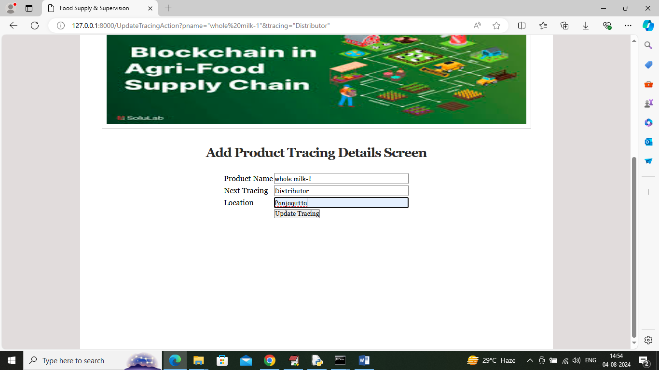

In above screen manufacturer is updating product trace to distributor after completing manufacturing and now logout and login as ‘Distributor’ to get below page

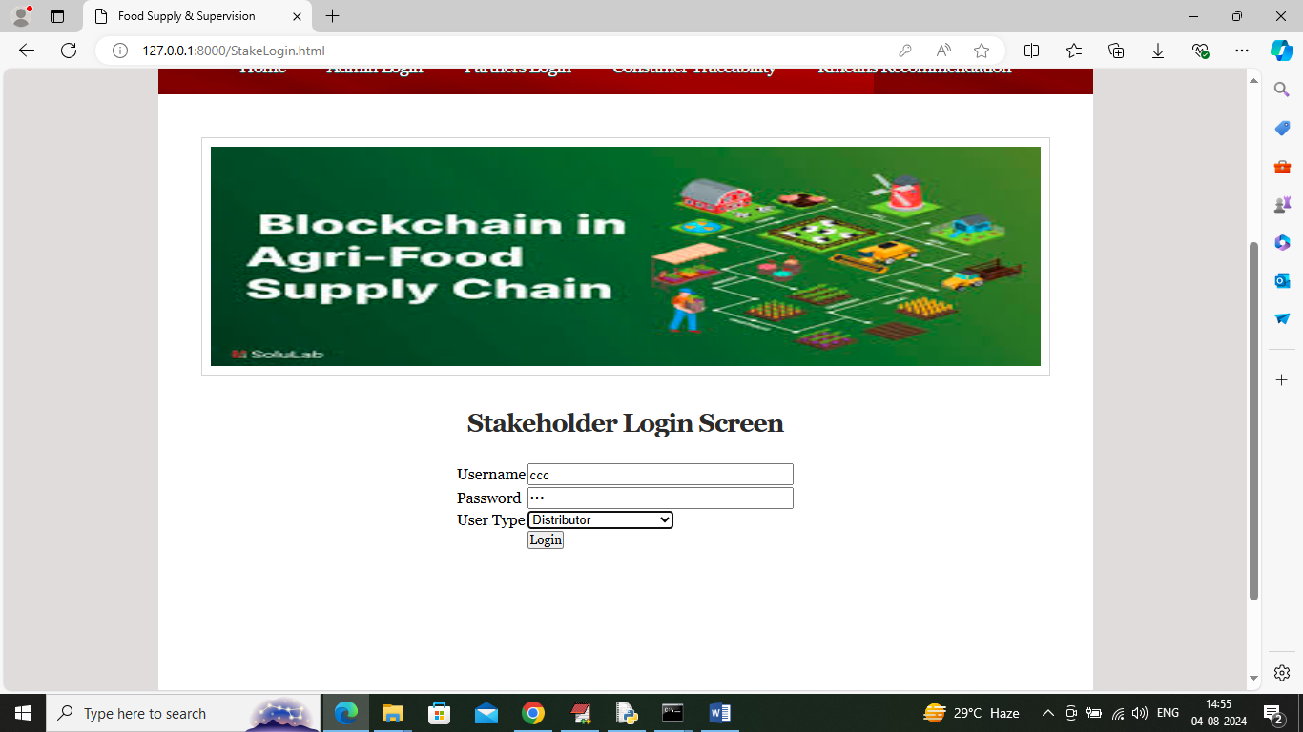

In above screen distributor is login and after login will get below page

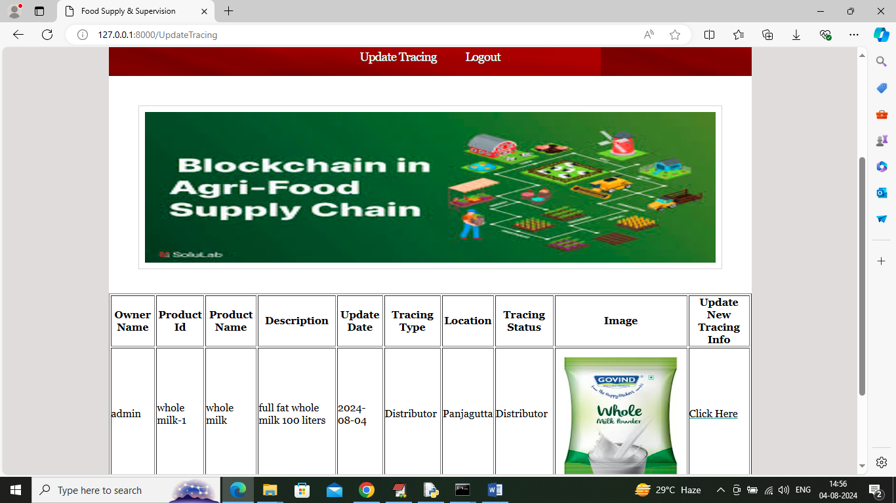

In above screen distributor can click on ‘Click Here’ link to update trace to retailer

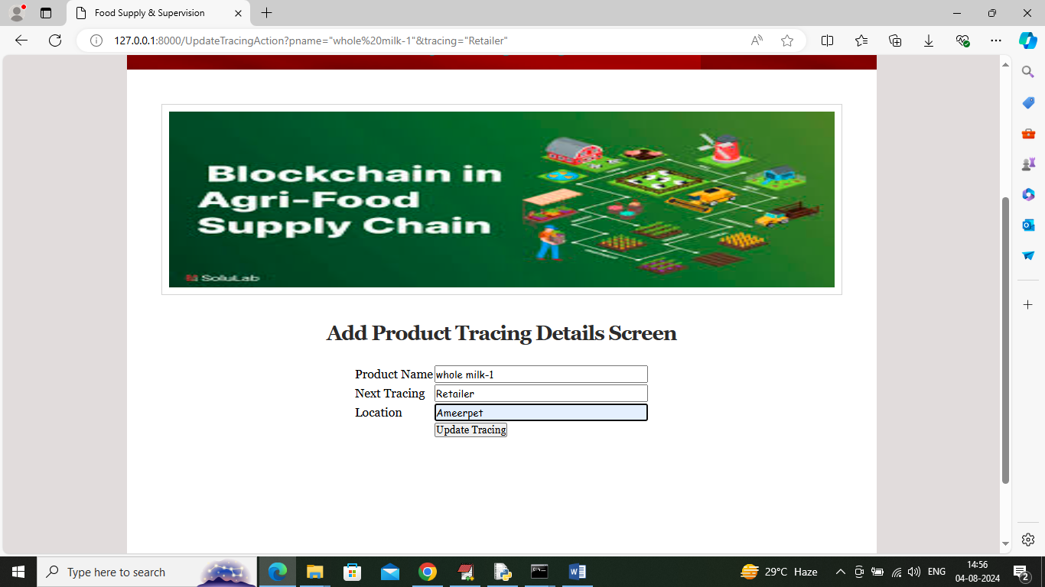

In above screen distributor sending order to Retailer and now logout and login as ‘retailer’ to sale to consumer

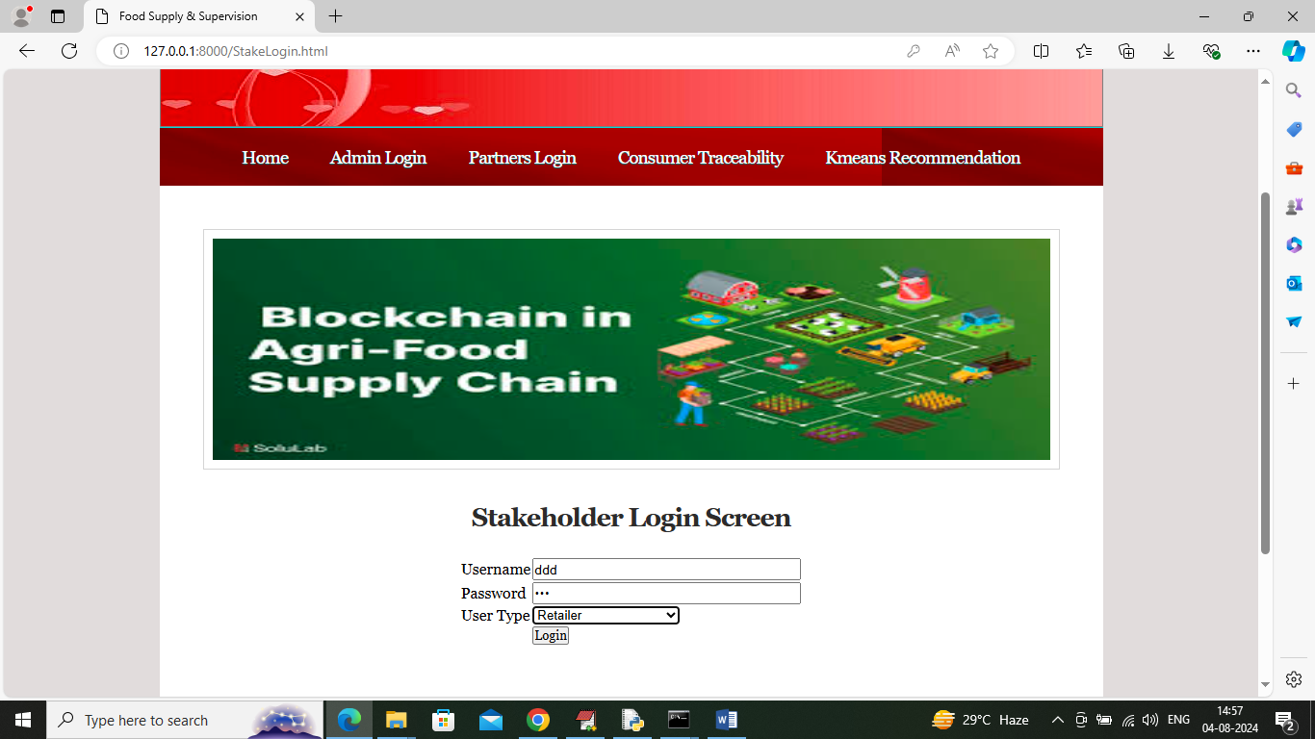

In above screen retailer is login and after login will get below page

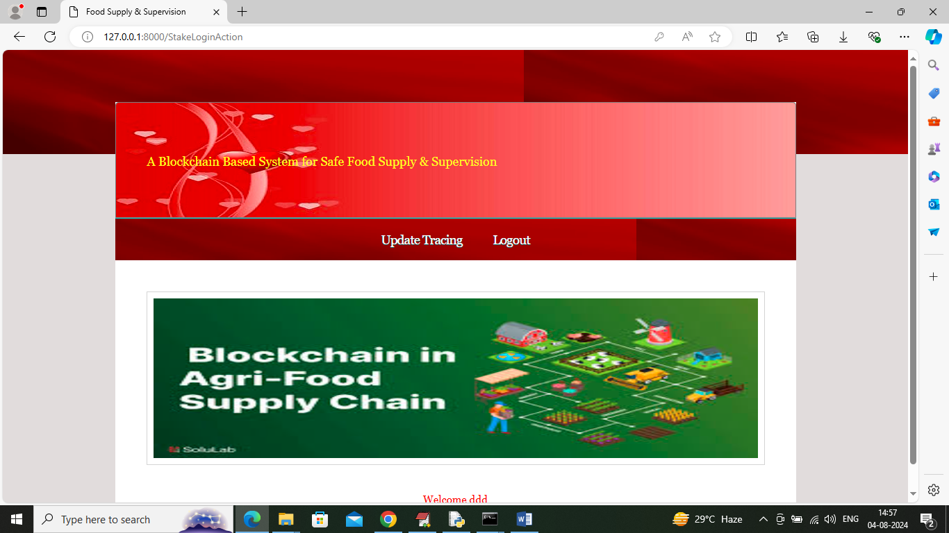

In above screen click on ‘Update Tracing’ link to get below page

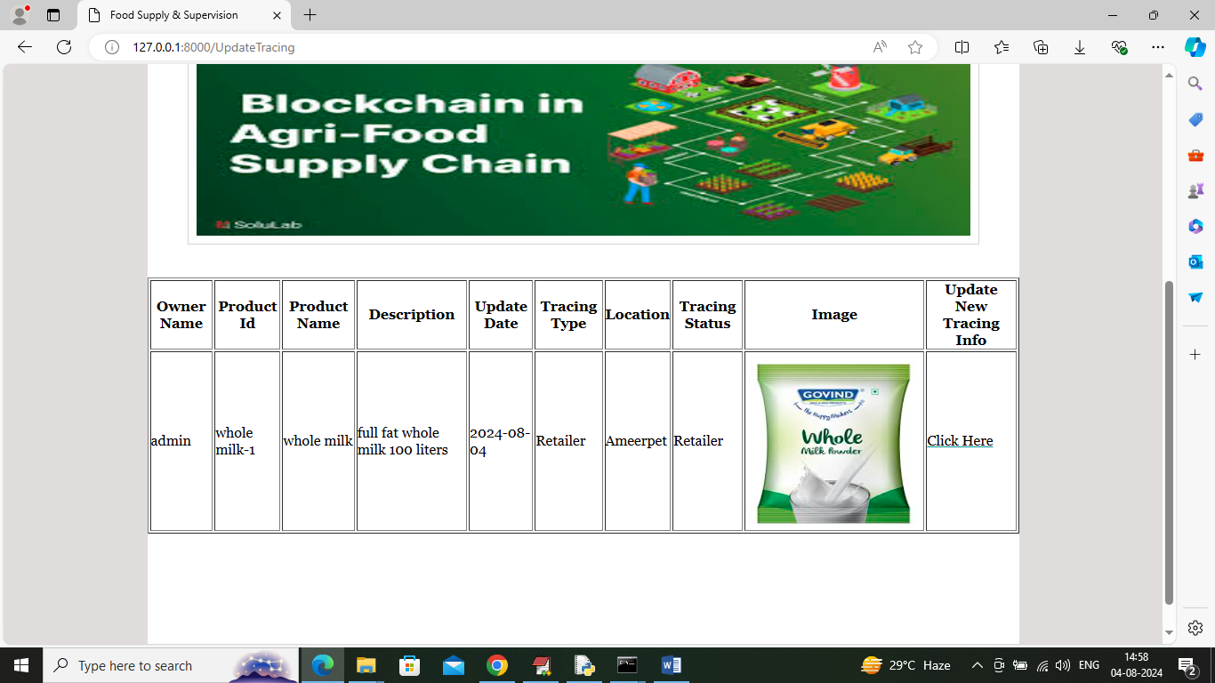

In above screen Retailer can click on ‘Click Here’ link to sale products to N consumer and get below page

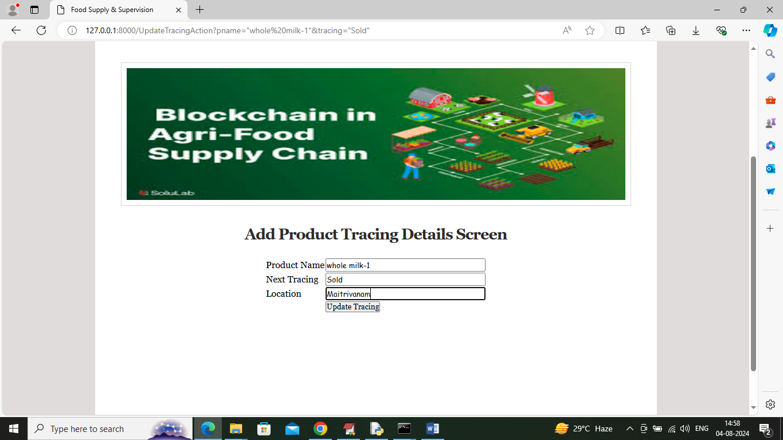

In above screen retailer is selling product to N consumer and by using this process each and every tracing details can be tracked and logout to get below page

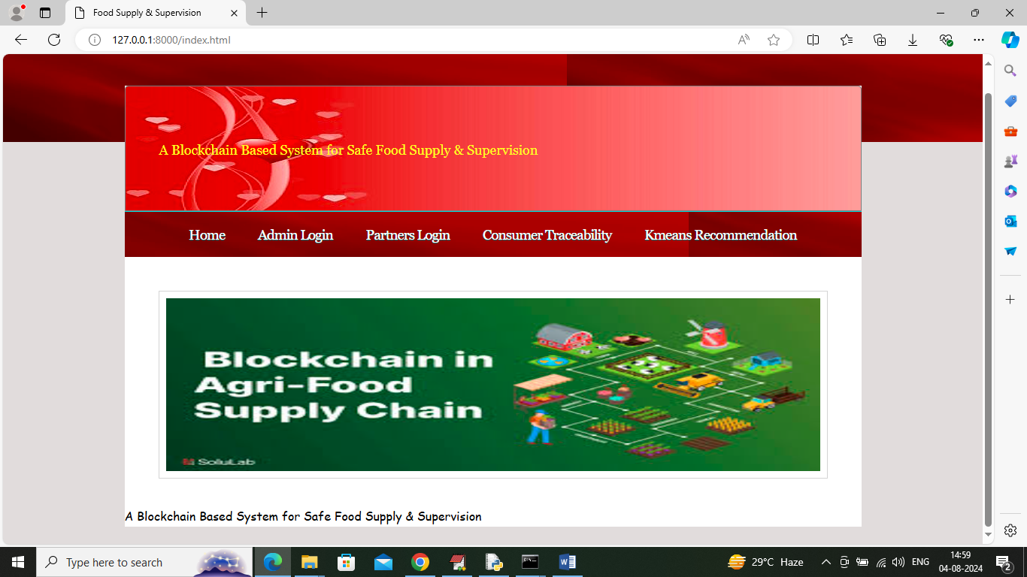

In above screen click on ‘Consumer Traceability’ link to get below page

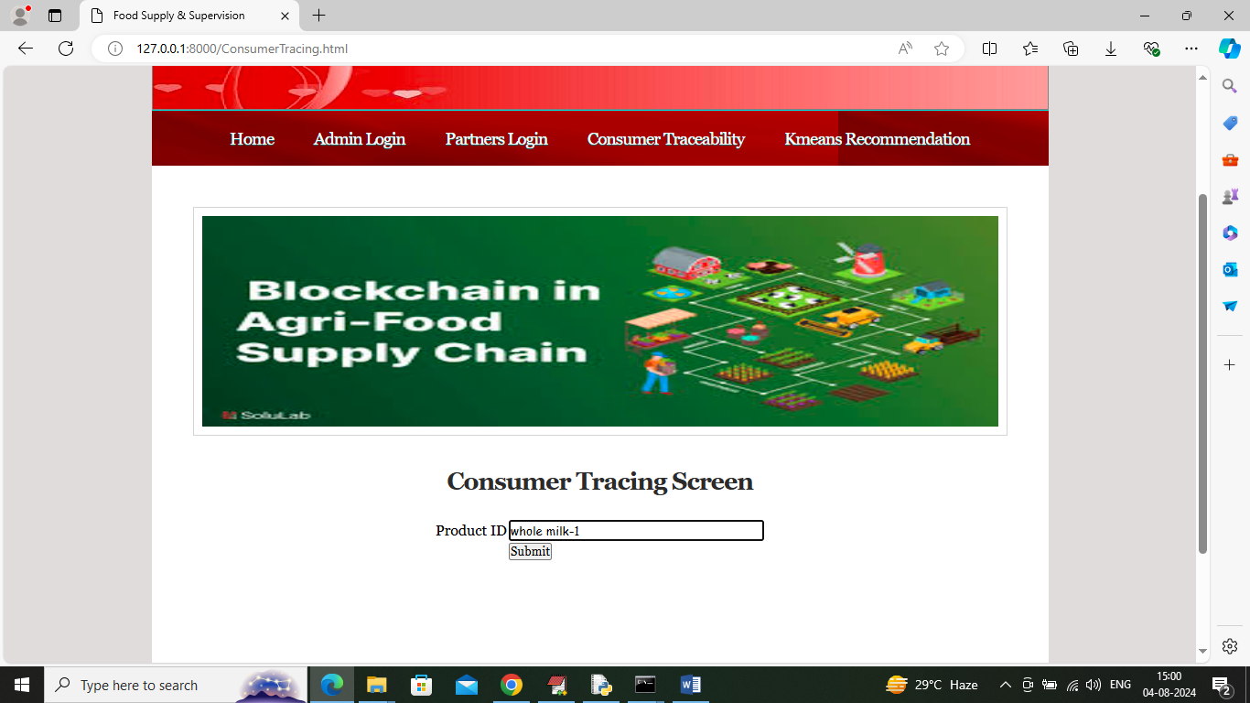

In above screen consumer will enter product ID of receive product and then press button to get below page

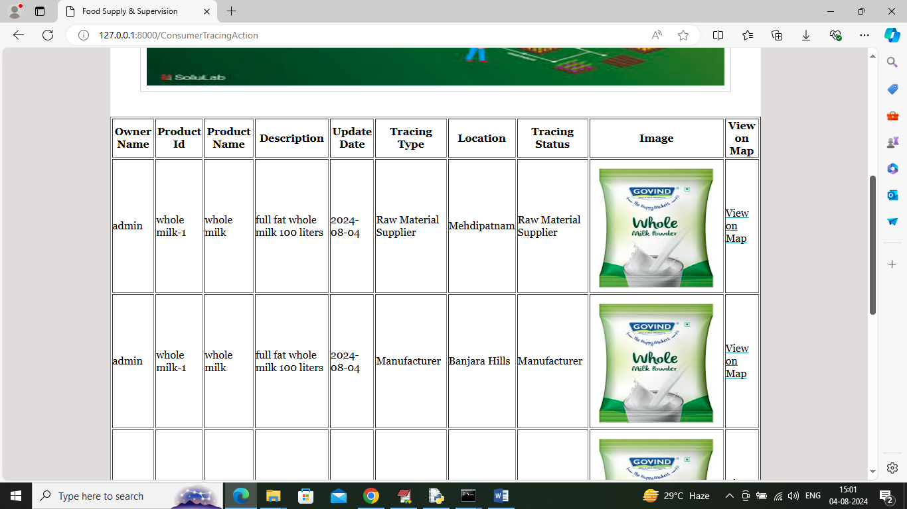

In above screen consumer can view or trace all stages of product processed and can click on ‘View Map’ link to view all trace location to map

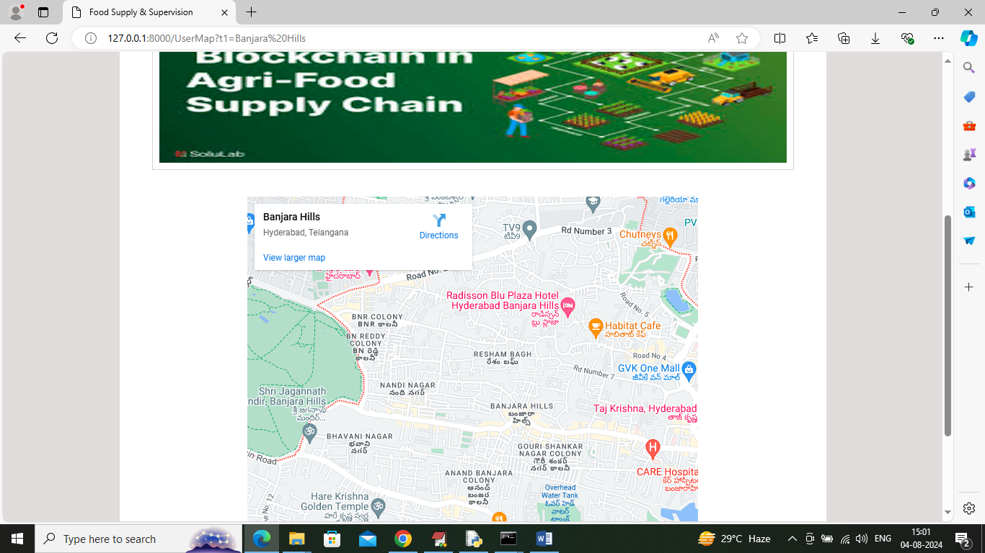

In above screen can see location map and now click on ‘KMEANS recommendation’ link to get below page

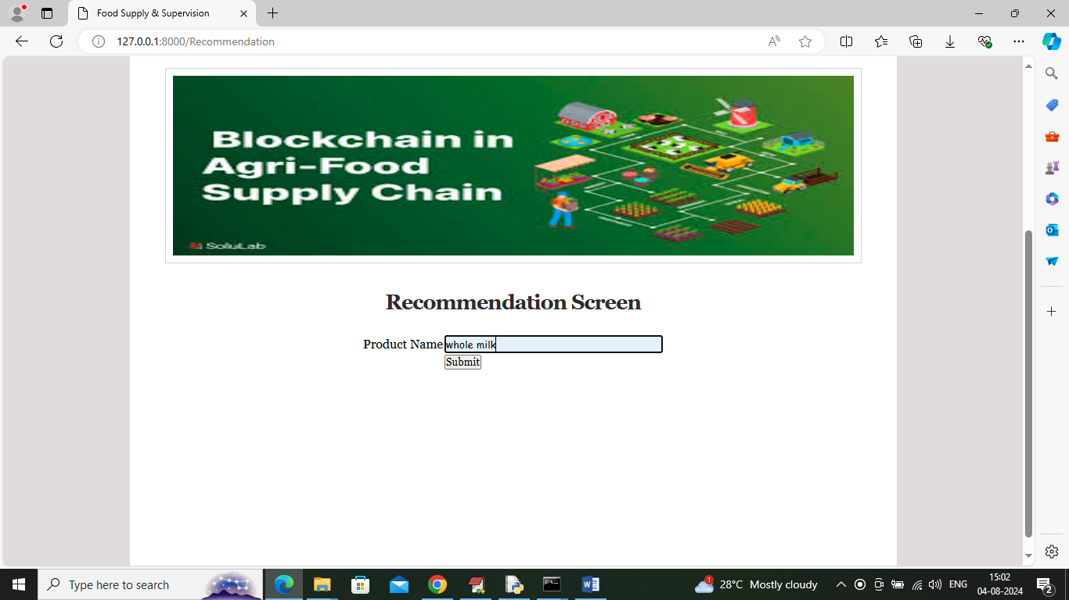

In above screen user is entering product name and then press button to get KMEANS based recommendation

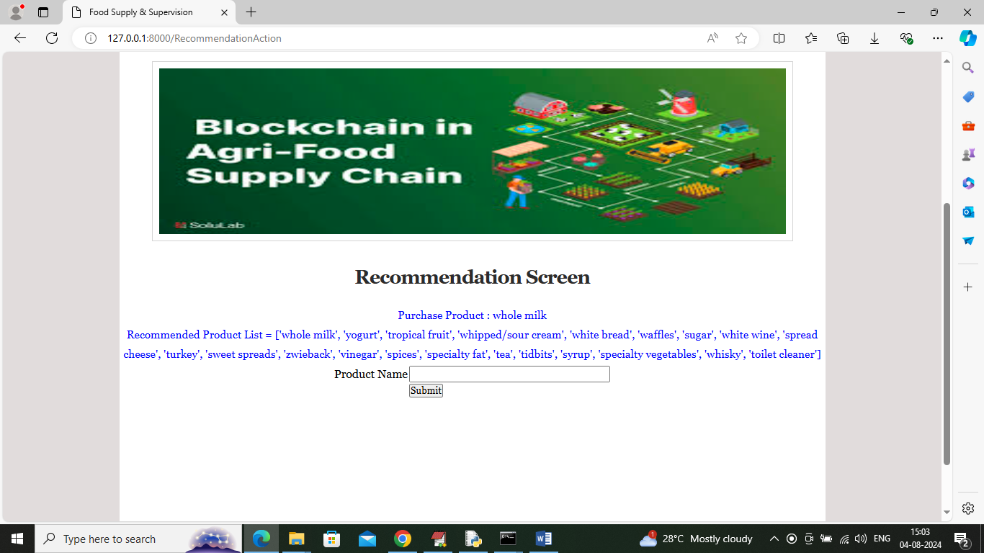

In above screen in blue colour text can see list or similar products as recommendation

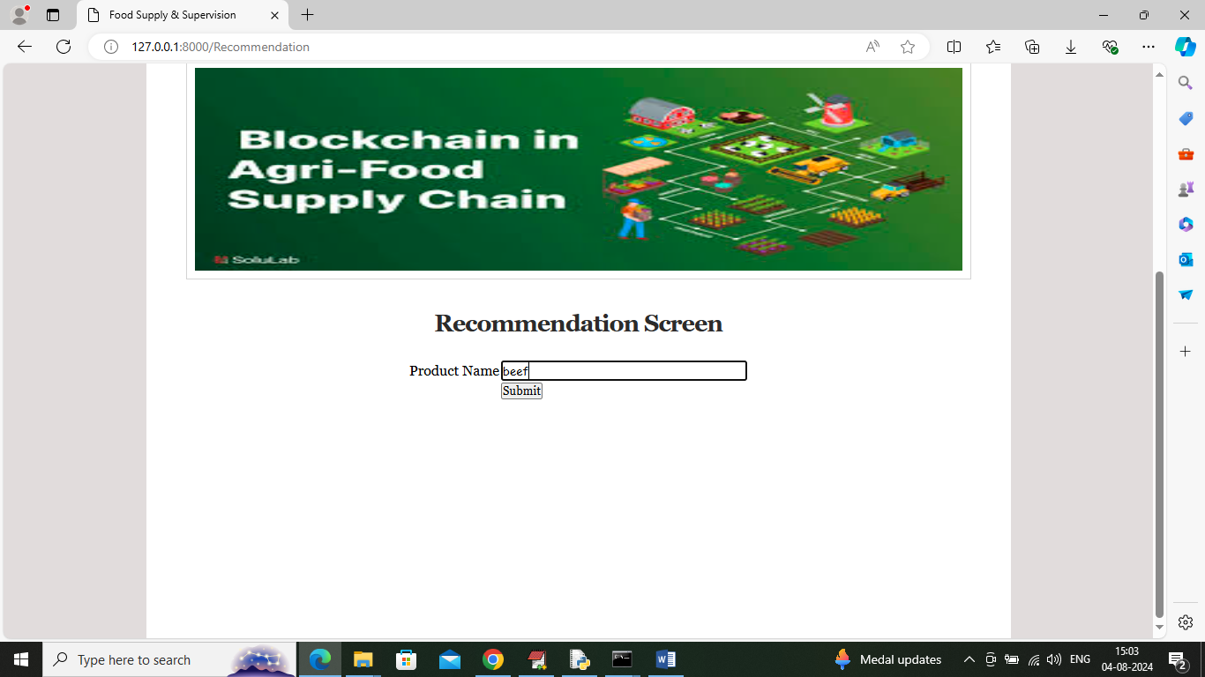

In above screen entering name as beef and below is the recommended output

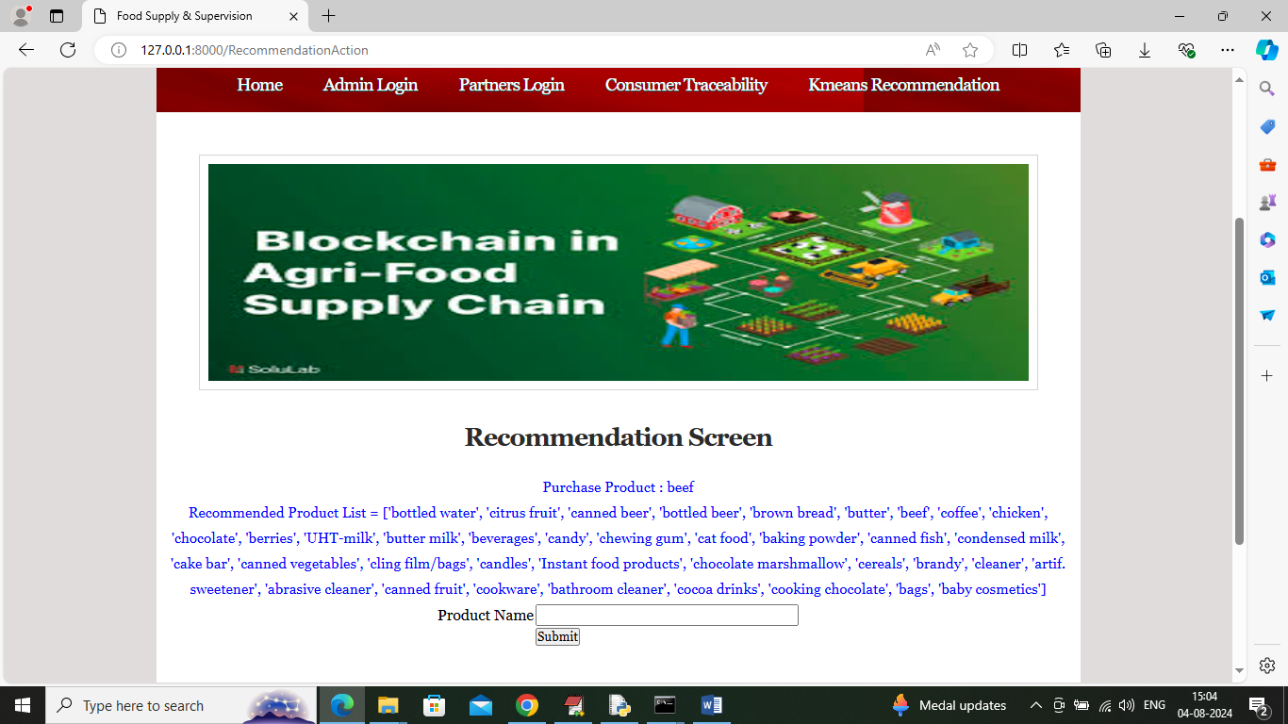

In above screen can see recommended list for ‘Beef’.

So by using above screens you can run project to trace product details, forecast and recommend items.